Title
Patient/Informal Carer Administration of Subcutaneous Intermittent Medication in Adult Palliative Care Policy
Date effective from: | December 2021 | Review date: | December 2024
Approved by: | NHSGGC NMAHP Governance Group Dec 2021  GGC PCCG Group Jan 2022
Approval Date: | Planned policy implementation date 1st March 2022
Author/s: | Short Life Working Group for Patient/Informal Carer Administration of Subcutaneous Intermittent Medication in Adult Palliative Care  *Author List in Appendix 1
Policy Owner: | NHSGGC Primary Care 6 HSCP Chief Nurses
Executive Lead: | Karen Jarvis Chief Nurse
Target Audience: | NHSGGC Primary Health Care Team
Supersedes:
Keywords (min. 5): | intermittent, subcutaneous injection, informal carer, patient, medication


NHSGGC is required by the Equality Act (2010) and its Public Sector Equality Duty (PSED) to evidence due regard to:
- Eliminate unlawful discrimination, harassment and victimisation
- Advance Equality of opportunity between different groups
- Foster good relations between different groups
In line with this Duty and recognising additional responsibilities as set out in the Equality Act 2010 (Specific Duties)(Scotland) Regulations 2012, this Policy has been Equality Impact Assessed and the resulting assessment published on the NHSGGC website.

Version Control

Date | Author | Version/Page | Reason for change
December 2021 | NHS Greater Glasgow and Clyde, Primary Care | 1

Executive Summary

This policy aims to support patients, and or informal carers, to administer prescribed subcutaneous medication by intermittent injections, if they wish to do so, in order to facilitate effective symptom control in people’s own homes. This policy has been amended for use in NHS GGC from one developed by NHS Lothian Primary Care, Marie Curie Hospice and St Columba’s Hospice (Edinburgh) and reflects clinical evaluation, current guidelines, expert consensus and feedback from staff, patients and informal carers. The policy details information regarding the scope, roles, responsibilities, and this aims to support patients, and or informal carers, to administer prescribed subcutaneous medication by intermittent injections, within NHS GGC Primary Care. It is not intended that this will become routine practice.

Contents

1 Glossary of Terms 4
2 Purpose 5
3 Policy Statement 5
4 Scope 5
5 Implementation Roles and Responsibilities 7
6 Regulatory Bodies 9
7 Associated Materials 9
8 Evidence Base 10
9 Stakeholder Consultation 10
10 Monitoring and Review 10
11 Associated Documents 10
Appendix 1 – Short Life Working Group Members 11
Appendix 2 – Record of Competency from the Teaching Guideline 12
Appendix 3 – Patient/Informal Carer Information Sheet 13

Glossary of Terms

End of life care: within this policy refers to care in the last days of life, when death is expected.
Informal carer: refers to an adult providing care for a patient with palliative care needs (most likely in the home environment) who is not employed to undertake this role. The likelihood is that they will be a family member.
Multi-Disciplinary Teams: group of professionals from one or more clinical disciplines who together make decisions regarding recommended treatment of individual patients.
Palliative care: aims to prevent and relieve pain and suffering throughout any serious illness as well as where death is impending, and in bereavement. The focus is holistic and person-centred care that enables people to live well, and when death is inevitable, to die peacefully and with dignity. Care and support for people extends to family and important others.
Subcutaneous administration: relates to the administration of prescribed medication via a subcutaneous cannula which has been inserted previously by a healthcare professional.

2 Purpose
This policy provides direction for staff working in NHS Greater Glasgow and Clyde Greater Glasgow and Clyde, Primary Care to support patients, and or informal carers, to administer prescribed subcutaneous medication by intermittent injections if they wish to do so to facilitate effective symptom control
This policy, and its associated materials, has been subject to literature review and comparison with evidence from other health boards/authorities across the UK.
This policy and associated guideline aims to:
    - Facilitate effective symptom control and offer patient choice and informal carer involvement
    - Afford patient and informal carers a greater understanding of the medicines prescribed, their indications, actions and side effects
    - Assist healthcare professionals in the teaching and assessment of patient/informal carers in a consistent and safe manner

3 Policy Statement
There is a greater emphasis on supporting patients and/or informal carers to become genuine partners in the delivery of care (Strategic Framework for Action on Palliative and End of Life Care 2015). This policy and related documents have been developed to support patients, and/or informal carers, who wish to be actively involved in the administration of subcutaneous medication by intermittent injections in adult palliative care. The NHS Greater Glasgow and Clyde NMAHP Governance Group reviewed and supports this policy, and its associated materials.
A crucial element of this support will be education and training to enable patients and or informal carers to be adequately prepared to undertake the task confidently and competently. Current evidence suggest that educational interventions delivered face to face supported by written and/or other resources and appropriate follow up have the potential to improve patient, family and informal carer knowledge and self-efficacy for pain management.

Scope

The patient/informal carer
This policy applies to adults receiving palliative care support at home in Greater Glasgow and Clyde, Primary Care. It is anticipated that this policy will be relevant only to a small number of patients. It is not intended that this will become routine practice. The appropriateness will depend on the individual patient’s wishes and their circumstances.
If the patient/informal carer has expressed a wish to be involved in the administration of subcutaneous medication by intermittent injections to maintain effective symptom control in adult palliative care, they must meet the eligibility criteria as defined below.
Health care professionals should adhere to medication policy and regulatory body standards.

Eligibility Criteria
An adult with unpredictable or complex symptoms requiring subcutaneous medication who:
- Wishes to self-administer medication, or have a designated informal carer do this.
- May require intermittent doses of breakthrough medication.
- Has an informal carer who has expressed a willingness to be involved in the administration of subcutaneous medication.
- Has provided informed consent and this is clearly documented in the clinical care record.
- Has successfully completed the teaching guideline and deemed competent: this requires reading, writing, numeracy skills and fine motor dexterity.
- Will be visited and supported on a daily basis by a community nurse.
- Where the ‘informal carer’ is a health professional and wishes to administer medication in line with this policy they must also complete the teaching education guide and be deemed competent to undertake the procedure as per policy.
- The use of alternative routes of administration of medication should continue to be explored.

Exclusion Criteria
A decision for any exclusion should be discussed with the multidisciplinary team and the reasons for exclusion clearly documented in the patients clinical care record.
- The health care professional assesses that the patient or informal carer would be unable to administer the medication due to physical, cognitive, or emotional reasons.
- Patients and informal carers aged less than 16 years.
- A patient or informal carer who has not received or successfully completed the agreed training (appendix 2).
- A patient or informal carer has a known history of substance misuse or there is someone with a known history of substance misuse who has access to the property.
- Where an informal carer will be administering the medication and there are concerns that the relationship between the patient and informal carer may compromise safety.

Care and support will continue to be provided by the multi-disciplinary care team, this may include specialist palliative care team if required.

Failure to adhere to the agreed plan of management or to maintain accurate drug administration documentation should immediately trigger a review of the suitability of the patient and/or informal carer to undertake the procedure. The occurrence of a drug error should also trigger such a review.

Any concern raised by any member of the healthcare team about the patient/informal carer meeting the inclusion or exclusion criteria should be discussed with the multidisciplinary team.

Medication Considerations

Medications that require to be reconstituted e.g. Diamorphine are excluded.

No dose ranges to be prescribed.

Each medication prescribed for a maximum of three subcutaneous doses per 24 hours, with guidance to seek advice and review if requiring more than 3 doses in 24 hour and/or if any dose ineffective.

Consent

The patient must consent to self-administration of subcutaneous medication or administration by named informal carer. Both the patient and carer should be aware that they may opt out of this care arrangement at any time and who to contact should they wish to do so.
In order for the patient and/or informal carer to give informed consent they require:
- Explanation of the rationale for the administration of intermittent subcutaneous injections.
- Explanation of the possible benefits and risks.
- Explanation of the potential impact on the informal carer of administering the last injection.
- An understanding of the information given to them.
- No feeling of pressure or coercion.

In order for informed consent to be given to undertake this role, the patient and/or informal carer must be aware of the existing medical and nursing services, particularly during Out of Hours periods available to them.

Implementation Roles and Responsibilities

Communication and Dissemination

This policy, and associated materials, will be distributed to Chief Nurses and Clinical Directors for cascading to all clinical areas providing palliative and end of life care.
To support ongoing access the policy, and associated materials, will be placed on the NHS Greater Glasgow and Clyde, Primary Care Palliative Care Website.

Management Team
Managers are responsible for the effective implementation of the policy in their area or have responsibility to ensure that all staff are made aware of this policy.
Managers are also responsible for gathering information of protected characteristics of patients and informal carers for the equality monitoring form, and postcode which will inform the Scottish Index Multiple Deprivation Data (SIMD). Managers will then forward this information to the Lead Primary Care Macmillan Pharmacist for Palliative Care who will collate this and monitor the frequency of its use across NHSGGC Primary Care.

The Community Nursing Team
The Community Nursing team who may be required to support a patient/informal carer undertaking administration of subcutaneous Intermittent medication admission;
- Know how to access the Patient/Informal Carer Administration of Subcutaneous Intermittent Medication in Adult Palliative Care Policy and Guidelines.
- Can demonstrate knowledge and application of the Patient/Informal Carer Administration of Subcutaneous Intermittent Medication in Adult Palliative Care Policy, Teaching Guideline and Information sheet.
- Know how to access the NHS Scotland Palliative Care Guidelines (2019) The Scottish Palliative Care Guidelines (2019) (Health Improvement Scotland/NHS Scotland) and local sources of help and information including the general practitioner, Greater Glasgow and Clyde, Primary Care, Single Point of Access (SPOA) where available for district nurses, pharmacy and specialist palliative care services in and out with normal working hours.
- Provide appropriate information and support to enable the patient and or informal carer, to participate in decision-making and care, to the extent they wish and are able to undertake this.
- Is responsible for removing and disposing of sharps boxes and any unused equipment.
- The District Nurse should inform the Team Lead if they have a patient or informal carer undertaking intermittent subcutaneous injection of medication using this policy.

Multi-disciplinary Team (MDT)
A collective decision, confirming that the patient or informal carer and circumstances meet the eligibility criteria, should be made by the multi-disciplinary team. A named professional, caring for the patient, most likely to be the district nurse, should be identified as the person responsible for teaching, monitoring and supporting the patient and/or informal carer.
The patient’s GP and/or DN must ensure the following is documented in the patients clinical care record:
- Assessment of eligibility criteria.
- Detail who was involved in the decision making.
- Informed consent to undertake the role has been given by the patient and named informal carer.
- Record of completion of teaching.

The Key Information Summary (KIS) should be updated by the GP.

The General Practitioner and where applicable community nurse prescriber must be involved in the MDT discussions. The decision to implement the policy must have his/her agreement as ongoing prescriber/s. This policy is applicable in Primary Care only.

Regulatory Bodies
Regulatory bodies provide professionals with clear and more detailed advice:

General Medical Council (GMC)
The GMC advises that when a doctor delegates the care of a patient to a colleague, he/she must be satisfied that the person providing care has the appropriate qualifications, skills and experience to provide safe care for the patient.
Further advice is provided in the publication Delegation and Referral (2013) advises that if a doctor delegates care he/she is still responsible for the overall management of the patient.

Nursing and Midwifery Council (NMC)
The NMC advises that the nurse is responsible for the delegation of any aspects of the administration of medicines and they are accountable to ensure that the patient, carer or care assistant is competent to carry out the task. A record of the individual’s training and assessment should be kept and all refresher or continuing education and training should also be routinely kept.
The NMC Code (section 11) provides more detailed advice on delegation.

Associated Materials
The NHS Greater Glasgow and Clyde, six HSCPs has reviewed and supports this policy, and its associated materials.
NHS Greater Glasgow and Clyde, Safe and Secure Handling Use of Medicines within Primary Care
Patient/Informal Carer Admission of Subcutaneous Intermittent Medication in Adult Palliative Care Guideline.
Administration of subcutaneous drugs by intermittent injection via BD Saf-T-Intima, blue 22 gauge, single lumen cannula
Teaching Guideline - Support for the patient/informal in the administration of subcutaneous medication by intermittent injections in adult palliative care
    - Using a BD Saf-T-Intima Cannula (blue) 22 gauge
    - How to prepare the syringe
    - How to give a subcutaneous injection via a needleless connection system through the BD Saf-T-Intima Cannula
    - Patient/Informal Carer intermittent subcutaneous injections: Medication Record/palliative care kardex
    - Patient/Informal Carer intermittent subcutaneous injections: Record of drugs given
    - Patient/Informal Carer information leaflet
    - Getting help
    - Record of competency

8 Evidence Base
GMC Good medical practice, General Medical Council, 2013
NHSGGC - A Safer Place to Work - Sharps
NHS Grampian Policy and Staff Guidance on Patient and Informal Carer Administration of Subcutaneous Medication by Intermittent Injection – Adult Palliative Care (2016)
NHS Lothian - Patient and Carer Administration of Subcut Intermittent Medication Guideline (2020)
NMC: The Code (2018) Professional standards for practice and behaviour for nurses, midwives and nursing associates
NMC: The Code (2018): Record Keeping for nurses, midwives and nursing associates (section 10)
The Royal Pharmaceutical Society Professional Guidance on the Administration of Medicines in Healthcare Settings (2019)
The Scottish Government Strategic Framework for Action on Palliative and End of Life Care (2015)
The Scottish Palliative Care Guidelines (2019) (Health Improvement Scotland/NHS Scotland)

9 Stakeholder Consultation
A multidisciplinary Short Life Working Group, instigated by the HSCP Chief Nurse Group, was established with representatives from across the six Local HSCPs, a Hospice Consultant and led by Palliative Care Lead Nurse/CSM (see Appendix 1).

Monitoring and Review
The following arrangements will be made to audit and monitor the effectiveness of this policy and its associated materials:
    - It will be the primary responsibility of nurse managers to initiate audits in their local area, to measure the impact of the policy, and associated guidance, on practice.
    - Any concerns raised regarding the policy, or complaints from use of the policy, should be directed to the Lead Nurse for Palliative Care and the Lead Primary Care Macmillan Pharmacist for Palliative Care.
    - Local policies for risk management, reporting and medicines should be followed.
    - Complaints will be monitored through the NHS Greater Glasgow and Clyde Complaints Procedure.
    - The policy will be reviewed every 3 years.
    - Nurses must ensure that accurate documentation is maintained at all times in accordance with the Nursing and Midwifery Council (2018) The Code: Professionals Standards of Practice and Behaviour for Nurses and Midwives, London

11 Associated Documents
Patient/Informal Carer Administration of Subcutaneous Intermittent Medication in Adult Palliative Care Teaching Guideline (Appendix 2)

Patient/Informal Carer Information Sheet for Administration of Subcutaneous Intermittent Medication (Appendix 3)

Appendix 1 – Short Life Working Group Members

Susan Addie | Palliative Care Pharmacist, St Vincent’s
Shirley Byron | Macmillan Nurse Facilitator Primary Care
Anne Dean | GMB
Nicola Dunne | Community Staff Nurse, East Dunbartonshire
Gayle Elder | NHSGGC Discharge Team, Clyde
Susanne Gray | Palliative Care Nurse, Dykebar
Annie Hair | Unite the Union – Senior PD Nurse, NE
Margaret Harkin | In-Reach DN - Inverclyde
Elayne Harris | Macmillan Lead Pharmacist Palliative Care
Anne McDaid | Royal College of Nursing – Support & Dev Lead NE
Lesleyann McFadyen | Community SN, East Glasgow HSCP/North
Stephanie McGroarty | Community Staff Nurse, East Dunbartonshire
Lynn McKendrick | Service Manager, NE Glasgow
Margaret-Anne O’Donnell | Clinical Team Lead, East Renfrewshire
Lynsey O’Dwyer | District Nursing Sister, East Renfrewshire
Patricia O’Gorman | Palliative Care Practice Development Facilitator
Claire O’Neill | Palliative Care Lead Nurse, CSM
Una Provan | Unison – Team Lead, South Sector
Fiona Taylor | Adult Community Nursing West Dunbartonshire
Graham Whyte | Consultant in Palliative Care, Marie Curie

As no GPs were able to attend the SLWG meetings the draft documents were sent to the Clinical Director of each of the six HSCPs to cascade for comment.

Appendix 2 – Record of Competency from the Teaching Guideline

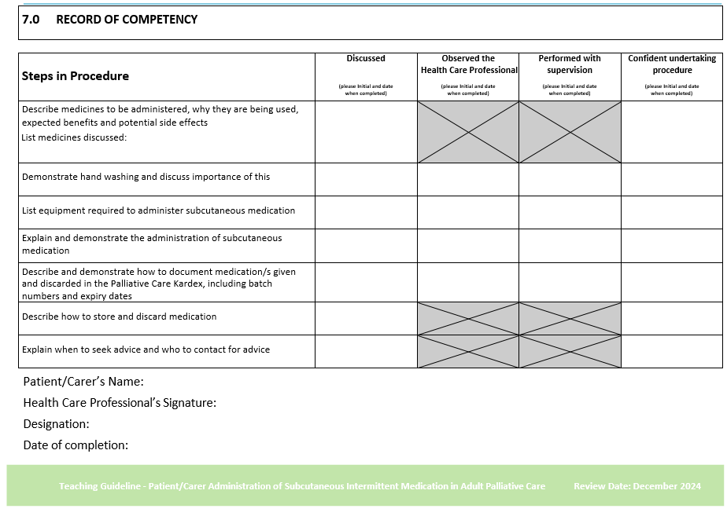


Appendix 3 – Patient/Informal Carer Information Sheet

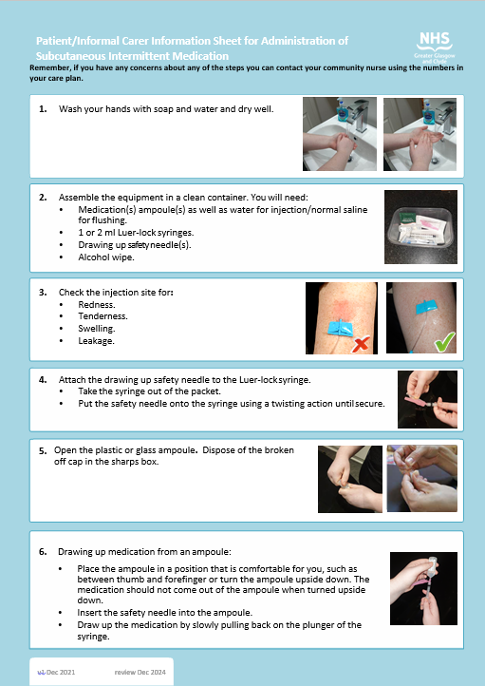

Appendix 3 – Patient/Informal Carer Information Sheet (continued)

