Not just painkillers

# Your pain and how you can help it

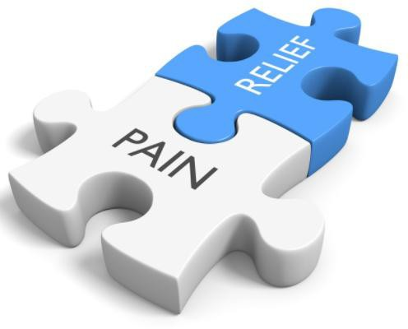

**Types of pain**

**Acute pain** happens when you injure something - for example if you stub your toe or strain your back. It can last from a few minutes to a few weeks. It will usually settle down as the injury heals.

**Chronic pain** carries on much longer even after the original injury has healed. It can continue for months or years.

Both types of pain can be mild or severe. What treatments will help the most with your pain will depend on whether it is acute or chronic.

# Pain medicines

Medicines are sometimes helpful for reducing pain, especially acute pain. **They are not usually helpful for chronic pain** and it is beneficial to use other approaches to managing your pain as well as, or instead of, medicines. It can be helpful to think of medicines as **pain relievers** rather than **painkillers**.

# Types of pain reliever

**Simple pain relievers:** such as paracetamol

**Anti-inflammatory pain reliever:** such as ibuprofen, diclofenac or naproxen

**Opioid pain relievers:** such as codeine, dihydrocodeine, tramadol, morphine, fentanyl, or oxycodone.

(Co-codamol is a combination of paracetamol and codeine. Co-dydramol is a combination of paracetamol and dihydrocodeine).

# Managing your pain

**Acute pain:** If you have an injury, pain relievers can be helpful in the short term, particularly if pain is making it difficult to move or sleep. Other treatment might include heat or cold packs, gentle exercise or stretching. If you are unsure, seek advice from your local pharmacy, physiotherapist or GP.

**Chronic pain:** Chronic pain is more difficult to treat - it is rarely possible to relieve long-term pain completely by using a pain medicine.

Medicines for long-term pain only benefit around one in every four or five people and on average only reduce pain by around a third.

Pain relievers work best if you combine them with other ways of managing your symptoms, like regular activity and exercise, social activities and doing things that are satisfying or enjoyable.

The aim of treatment is to reduce your pain enough to help you get on with your life. Setting goals can be an important way to see if the medicines are helping.

# Opioid pain relievers

Opioids are strong pain medicines which can be really useful for a short time to help with your recovery after an injury or operation. However, they can cause troublesome side effects and studies show they’re not effective in the longer term for pain that’s not related to cancer.

It’s best that you don’t take them for any longer than you need to.

# Side effects of opioid pain relievers

Opioid pain relievers can cause side effects such as:

* Constipation and nausea (feeling sick)
* Feeling drowsy, dizzy or confused
* Increased risk of having a fall.

When used for many months or years, opioids can cause:

* Weight gain
* Problems sleeping, including snoring or difficulty breathing
* Poor concentration and poor memory
* Reduced sex drive, erectile dysfunction, infertility
* Mood changes
* Immune system effects, increased risk of infections
* Increased risk of broken bones
* Increased sensitivity to pain.

Other problems with long term use can be:

**Tolerance**, where your body gets used to the opioid, so the same dose is less effective than it used to be

**Addiction** with psychological dependence and behaviour patterns

**Dependence** with withdrawal symptoms if the opioid is stopped suddenly

# How can I reduce or stop taking opioid pain relievers?

It is important that you don’t stop taking an opioid suddenly.

If you have been taking an opioid pain reliever and would like to stop, please speak to your GP or pharmacist. We will use a plan to gradually reduce your opioid dose safely over a number of weeks.

# Other approaches to managing pain

It is common for people with long-term pain to feel that they have no control over pain and are unable to cope with it. Pain can affect people in lots of different ways. You might have difficulty managing at home or work. You may not enjoy your usual activities or time with family and friends. You may have problems with sleeping.

Small changes can make a big difference to how much your pain affects your quality of life. See below for advice on simple things you can do which may help in dealing with pain:

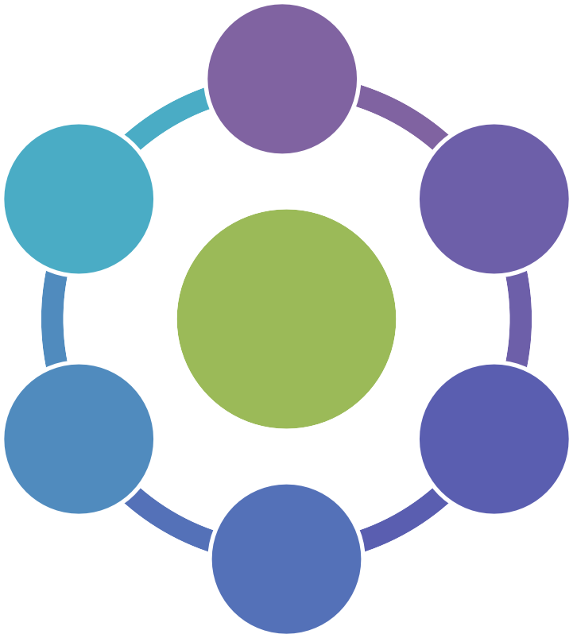

**learn**

**sleep well**

**exercise**

Help your pain

**breathe**

**connect**

**relax**

**Practical applications:** Using heat or cold packs regularly, or TENS machines (if you have one) can help to make your pain more manageable.

**Get some gentle exercise:** Simple activity (such as walking, swimming or light gardening) can help to lessen pain by stretching stiff and tense muscles. See the DG Doing more website link below for local activites.

**Learn to relax:** Relaxation can help to control your pain. Learning a relaxation technique (such as mindfulness or yoga) and setting aside time each day to practice it can reduce pain and help you feel more in control.

**Breathing exercises:** Try to control your breathing by breathing gently into your tummy rather than taking rapid, shallow breaths from your chest. This will help you to feel more in control. It will help manage muscle tension or anxiety from worsening your pain.

**Sleep well:** Evidence suggests that not getting enough sleep can worsen pain. Try to establish a good sleep routine; go to bed at the same time each night, and get up at a regular time in the morning.

**Distract yourself:** An activity which you enjoy and needs some concentration will shift your attention to something else other than your pain.

**Communication:** Get out of the house and don’t lose contact with people - speak to family members. Catch-up with friends and tell them how you feel.

**Education:** Increase your knowledge about pain and coping strategies by visiting the websites in the information section below.

# Making Changes with Community Link Worker Support

Community Link Workers understand that you may be feeling anxious about making changes and are not sure where to start or where to get help.

Community Link Workers understand that non-medical concerns can have an impact on your health and wellbeing. For example; caring responsibilities, worries about the cost of living or feeling isolated.

Community Link Workers can work alongside you to understand the things that matter to you in managing your health. They can support you to make plans and take steps towards keeping well and living the life you want.

They can help you to connect to the people, places and resources in the community that may help.

For example;

• Local activities and social groups

• Self-help and support groups

• Money and benefit advice, debt management and budgeting

• Care services and carers support groups

• Volunteering opportunities

• Getting into work, training and education

If you think support from a Community Link Worker would be helpful for you or for someone you know, please telephone **030 33 33 3001.** A friend, carer or family member can make the call on your behalf, with your permission.

The team who answer the phone will ask some questions to help us make sure we get you to the right people to support you in your local area.

If you need help or support to get in touch, your GP or Health Professional can refer you directly to a Community Link Worker with your consent.

# Where can I get more information?

## NHS Inform

[www.nhsinform.scot/illnesses-and-conditions/brain-nerves](https://www.nhsinform.scot/illnesses-and-conditions/brain-nerves-%20and-spinal-cord/chronic-pain) [and](https://services.nhslothian.scot/painmanagement/AAH/Pages/default.aspx)-spinal-cord/chronic-pain

[www.nhsinform.scot/illnesses-and-conditions/mental-health](http://www.nhsinform.scot/illnesses-and-conditions/mental-health)

[https://www.nhsinform.scot/healthy-living/mental-wellbeing/five-steps-to-mental-wellbeing](https://www.nhsinform.scot/healthy-living/mental-wellbeing/five-steps-to-mental-wellbeing#mindfulness-for-mental-wellbeing)

## Other websites

<https://www.flippinpain.co.uk/>

<https://livewellwithpain.co.uk/>.co.uk

<https://www.paintoolkit.org/pain-tools>

<https://painassociation.co.uk/>

<https://www.nhs.uk/mental-health/self-help/guides-tools-and-activities/breathing-exercises-for-stress/>

## Local Classes

<https://dgdoingmore.co.uk/> (local activity classes)

## Video

Understanding Pain in less than 5 minutes: [www.youtube.com/watch?v=C_3phB93rvI](http://www.painconcern.org.uk/)

Tame the Beast – it’s time to rethink persistent pain

<https://www.youtube.com/watch?v=ikUzvSph7Z4>

Understanding Pain - Brainman stops his opioids

<https://www.youtube.com/watch?v=MI1myFQPdCE>

NHS Highland – Finding your zone of tolerance

<https://www.youtube.com/watch?v=g8xgWFRG0-Q&feature=youtu.be>

## [Apps](http://www.flippinpain.co.uk/)

[https://www.headspace.com/meditation](https://www.headspace.com/meditation?origin=navigation)

Not just painkillers V3.0

Thanks to NHS Lothian for producing this leaflet