Purpose and Scope

NHSGGC Radiology Services are responsible for the encrypted transfer of images via the Sectra Image Exchange Portal. This end user guide should be used as a reference for those requiring assistance to download their requested images.

Actions

- Once requested images are available, the requestor will receive an e-mail containing a link to follow to log in to the system and generate a onetime passcode. Once logged in, the user will be able to the view the images online, forward them to another recipient or download them to their system.

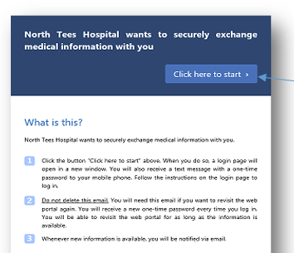
Click this link to be sent onetime passcode. This will be sent to the mobile number or secondary email provided at time of requesting images to be transferred.

The codes can only be used once and are time limited.

- On logging in, the user will arrive at their IEP dashboard.

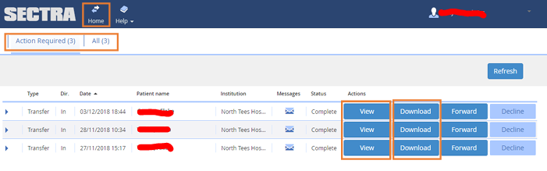
There are now three options. Click on the relevant button:

Home – to be taken back to the main page
Action Required – contains the user’s new transactions
All – contains all the transaction in the last 28 days for that specific user

Within Action Required, the user has three options:

View – will launch a new window to view the transferred images online
Download – allows for downloading of images and saving them on pc
Forward – allows images and online DICOM viewer to be forwarded directly to other recipients e.g. lawyer

- Downloading images
If the user wishes to download the images, this is downloaded in a zip file. The zip file can then be sent via email to additional users.

Please note, you cannot download the files to an I-Pad

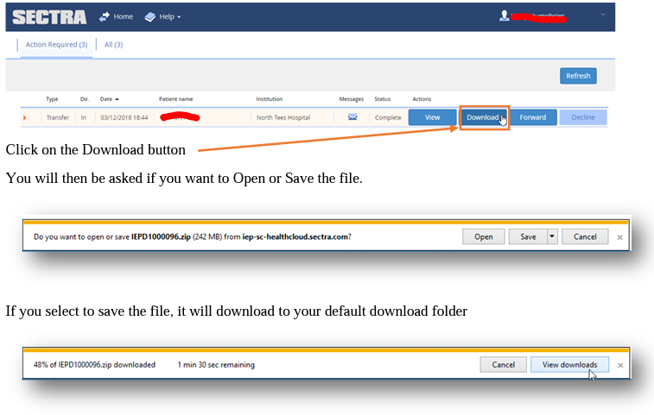
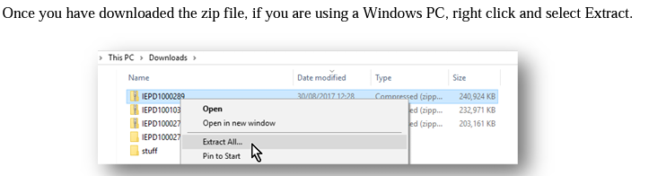
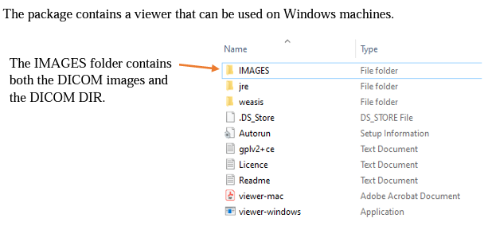

- Forwarding images

If the user requires to forward images received, they can do so from within IEP. Images can only be forwarded a maximum of three times. The recipient can download the images, but cannot forward them on again using IEP.

