Guidance on Acute Management of Implantable Cardioverter Defibrillators (ICD’s) in the community setting

The algorithm overleaf is to provide guidance to community teams in the acute management of patients who are presenting acutely unwell with an arrhythmia and have an ICD in situ.

The diagram below demonstrates the placement of the ring magnet on the patient’s chest to enable emergency deactivation of the defibrillator, if required.

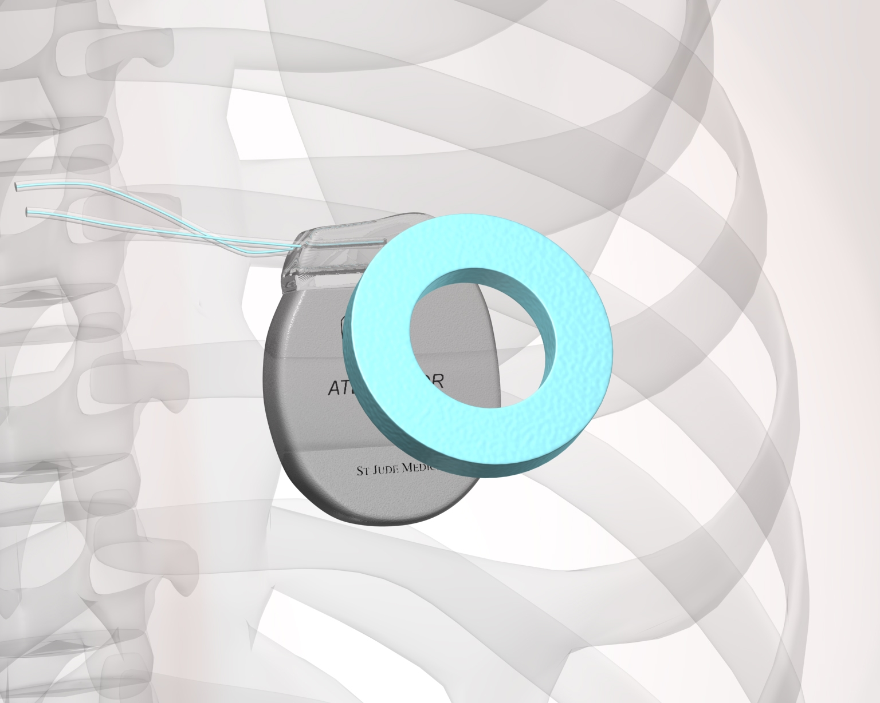 | 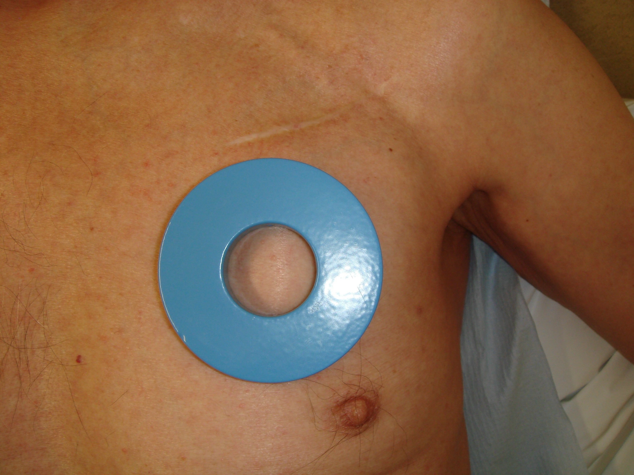

Ring magnets can be found in all community hospitals and emergency care facilities within northern NHS Highland. If a magnet is required – please contact Cardio Respiratory Department on 01463 704249 for further assistance.

North and West Operational Unit | South and Mid Operational Unit
- Caithness General Hospital, Wick  - Town & County, Wick  - Dunbar Community Hospital, Thurso  - Lawson Memorial Hospital, Golspie  - Migdale Hospital, Bonar Bridge  - Portree Hospital  - Mackinnon Memorial Hospital, Broadford  - Belford Hospital, Fort William | - Raigmore Hospital, Inverness  - Royal Northern Infirmary, Inverness  - Highland Hospice, Inverness  - Town and County Hospital, Nairn  - Aviemore Health Centre  - Ian Charles Hospital, Grantown on Spey  - County Community Hospital, Invergordon  - Ross Memorial, Dingwall

Warning – Document uncontrolled when printed
Policy Reference: Guidance on acute management of ICD’s | Date of Issue: November 2012
Prepared by: Amanda Smith and Catriona MacDonald | Date of Review: November 2014
Lead Reviewer: Dr Stephen Cross | Version: 1
Authorised by: Resuscitation Committee | Page 1 of 2
Guidance on Acute Management of ICD’s
Yes
No
Was the shock effective?
No
Yes
Yes
Is the ICD delivering therapy?
No
Yes
Was therapy appropriate?
Yes
No
Standard post arrest care as per ALS guidelines
Treat as per ALS guidelines
Is the patient in Cardiac Arrest?
Was therapy successful?
Place ring magnet over device to disable inappropriate therapy
No
Yes
Refer to ALS guidelines
Treat as per clinical findings
Yes
No
Contact local ICD Centre for further help and assistance
No
No
Yes
Does the patient have an arrhythmia?
Atrial flutter, atrial fibrillation, SVT, ventricular tachycardia
Is the ICD delivering therapy?

Is the ICD delivering therapy?

NB: It is safe to touch a patient when the ICD is delivery therapy

Additional Support available from:
Office hours: Cardio Respiratory Department, Raigmore Hospital, Inverness
Tel: 01463 704249
Out of Hours: Coronary Care Unit, Raigmore Hospital, Inverness
Tel: 01463 705849

If further support required, the telemed ECG service is available through the
Coronary Care Unit, Raigmore Hospital, Inverness

