**TRAUMA TEAM LEADER CHECKLIST**

**Pre Arrival**

|  |  |
| --- | --- |
| Confirm appropriate tiered response activated |  |
| Allocate roles |  |
| Ensure PPE worn by team |  |
| Prepare trauma mattress (NOT IF PENETRATING) |  |
| Pre-alert CT |  |
| Brief team members |  |
| * Clarify ability/experience including thoracotomy capability * Ensure team booked in with Scribe * Confirm role and priorities on arrival of patient * Plan for initial resuscitation/investigation * Reinforce team behaviours |  |
| Pelvic binder on trolley |  |
| US ready (confirm individual competent to perform) |  |
| Digital Clock ready |  |
| Draw up 10mg Morphine |  |
| Reception ready to book patient in (ALL CODE RED) |  |
| Preload CXR Cassette (ALL CODE RED) |  |
| Prime Belmont with RCC (ALL CODE RED) |  |
| Bair Hugger Under blanket on trolley (All Code Red) |  |

**On Arrival**

|  |  |
| --- | --- |
| ATMIST Handover |  |
| Transfer Patient as per SOP |  |
| Aim For CT and/or theatre within 30 minutes |  |
| TXA if not given prehospital |  |
| IV Cefuroxime 1.5g (& metronidazole if significant contamination) for open fractures |  |
| Ensure SAS/EMRS/MEDIC 1 patient record form & Pre alert form completed |  |

TTL NAME:

STAND DOWN CODE RED once appropriate. Return & preserve blood products as able.

South East Scotland Trauma Network

Age

Mechanism

Gender

Time of incident

Date

Injuries Suspected

Requirements

Pre Alert

**ED Trauma Documentation**

Arrival by:

Road Air

Pre-hospital: SAS

Medic One EMRS SCAA MOD

Coastguard

Standby Received:

Time received:

**Affix Label Here**

|  |  |  |  |  |  |  |
| --- | --- | --- | --- | --- | --- | --- |
| Signs | RR | SpO2 | HR | BP | / | Type of Activation: |
|  | GCS | BM | Temp |  |  | ED |
| ETA | |  |  |  |  | Enhanced Code Red  Time of activation: |

|  |  |  |  |  |
| --- | --- | --- | --- | --- |
| SPECIALTY | NAME | GRADE | ARRIVAL TIME | CONSULTANT |
| Trauma Team Leader |  |  |  |  |
| Anaesthetics |  |  |  |  |
| ODP |  |  |  |  |
| General Surgery |  |  |  |  |
| Orthopaedics |  |  |  |  |
| Critical care |  |  |  |  |
| Vascular |  |  |  |  |

L

Pre Hospital Handover

Time of Arrival:

**Time of Incident:**

**Age & Sex:**

Mechanism of Injury:

Injuries Sustained:

|  |  |
| --- | --- |
| **Signs & Symptoms:**  A –  B –  C –  D –  E – | GCS E V M BP  RR HR SATS |
| **Treatments / Trends:**  A – Self NP Guedel LMA RSI CRIC Collar  B – Thoracostomy Thoracotomy O2  C – Fluid Blood Cannula IO TXA Splint  D –  E – Binder Femoral | |
| **Drugs Administered**  Blood in mls: Fluid in mls: Other: |  |

Other information:

Primary Survey

Assessment Intervention

External haemorrhage SiteY

N

Tourniquet/site

Site

Haemostatics

<C>

A

Clear Compromised

Basic RSI

Surgical Collar NG/OG

|  |  |  |  |  |  |  |
| --- | --- | --- | --- | --- | --- | --- |
| B | Air Entry Visible Wound | R R | L L | O2  Thoracostomy |  |  |
|  | R | L |
|  | Tenderness | R | L | Chest Drain | R | L |
|  | Crepitus  Surgical Emphysema | R  R | L  L | CXR Comments |  |  |
|  | 1st RR |  |  |  |  |  |
|  | 1st SpO2 |  |  |  |  |  |

C

Abdomen Pelvis

Long Bones 1st Cap Refill 1st HR

1st BP

Pelvic Binder Fluids (mls)

Blood (mls)

TXA

PXR Comments

FAST Report (include name of operator)

D

Head Injury

GCS E ….. V…… M……

Pupils R .......... mm Reactive Y/N Priapism

L .......... mm Reactive Y/N

Blood Glucose Urinary catheter

HCG

Limbs Mvt LUL LLL RUL RLL

Urine

E

1st Temp

Bair Hugger Warm Blankets

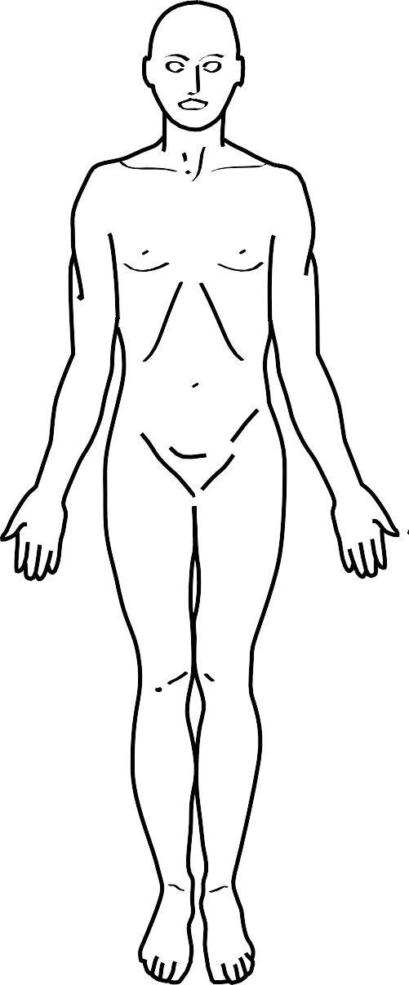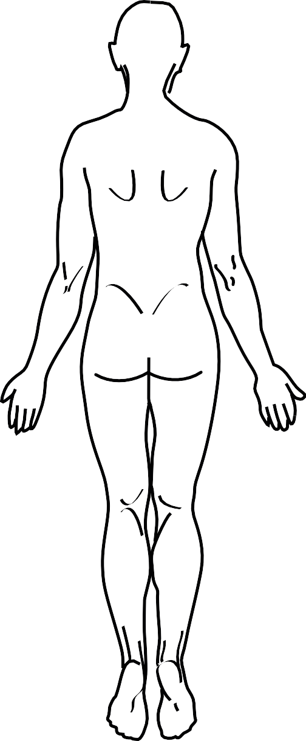

Y

N

Tetanus

Antibiotics

Time

A M P L

E

Secondary Survey

|  |  |
| --- | --- |
| **Key** |  |
| Tenderness/Pain | T |
| Abrasion | A |
| Bruising | //// |
| Fracture | # |
| Laceration (cm) | +++ |
| Incision | O |
| GSW | X |
| Swelling | S |

Secondary Survey/Injury Summary

|  |  |  |  |
| --- | --- | --- | --- |
|  | **Injuries** | **Investigation Results** | **Outstanding Tasks** |
| Head |  |  |  |
| MaxFax/ENT |  |  |  |
| T / L spine |  |  |  |
| C Spine/neck |  |  |  |
| Chest |  |  |  |
| Abdomen |  |  |  |
| Pelvis |  |  |  |
| Upper Limbs |  |  |  |
| Lower Limbs |  |  |  |
| Perineum, rectum, vagina. |  |  |  |
| Skin |  |  |  |

In Spinal Injuries please print separate ASIA Chart. In Burns please print separate Burns Chart.

Trauma Time Line

|  |  |  |
| --- | --- | --- |
| Time | List of Events/Decisions | Signature |
|  |  |  |

Trauma Time Line

|  |  |  |
| --- | --- | --- |
| Time | List of Events/Decisions | Signature |
|  |  |  |

Invasive Devices Record

|  |  |  |  |  |  |  |  |  |  |  |  |  |  |  |  |  |  |  |  |  |  |  |  |  |  |  |  |  |
| --- | --- | --- | --- | --- | --- | --- | --- | --- | --- | --- | --- | --- | --- | --- | --- | --- | --- | --- | --- | --- | --- | --- | --- | --- | --- | --- | --- | --- |
| **Peripheral Venous Catheter** | | | | | | | | | | | | | | | **Peripheral Venous Catheter** | | | | | | | | | | | | | |
| **Date: Time:** | |  | **Operator:** | | | | | | | |  |  |  |  | **Date: Time:** | | **Operator:** | | | | | | | |  |  |  |  |
| **Size (circle): Blue** | |  | **Pink Green Brown** | | | | | | | |  | **Grey** | |  | **Size (circle): Blue** | | **Pink Green Brown** | | | | | | | |  | **Grey** | |  |
| **Site:** Right Left **Hand** ACF Forearm Foot | | | | | | | | | | | | | | | **Site:** Right Left **Hand** ACF Forearm Foot | | | | | | | | | | | | | |
| **Procedure Checklist:** | |  | **Difficulties/Complications:** | | | | | | | |  |  |  |  | **Procedure Checklist:** | | **Difficulties/Complications:** | | | | | | | |  |  |  |  |
|  | | |  | | | | | | | | | | | |  | |  | | | | | | | | | | | |
| Hand hygiene |  |  | Hand hygiene |  |
|  | | |  | |
| CHG skin prep |  |  | CHG skin prep |  |
|  | | |  | |
| Aseptic insertion |  |  | Aseptic insertion |  |
|  | | |  | |
| Needle free port |  |  | Needle free port |  |
|  | | |  | |
| Dressing dated |  |  | Dressing dated |  |
|  | | | 1 | 2 | 3 | 4 | 5 | 6 | 7 | 8 | 9 | 10 | 11 | 12 |  | | 1 | 2 | 3 | 4 | 5 | 6 | 7 | 8 | 9 | 10 | 11 | 12 |
| **Days in situ** |  |  | **Days in situ** |  |
|  | | |  |  |  |  |  |  |  |  |  |  |  |  |  | |  |  |  |  |  |  |  |  |  |  |  |  |
| Site Clean Y/N |  |  | Site Clean Y/N |  |
| Still req’d Y/N | | |  |  |  |  |  |  |  |  |  |  |  |  | Still req’d Y/N | |  |  |  |  |  |  |  |  |  |  |  |  |

|  |  |  |  |  |  |  |  |  |  |  |  |  |  |  |  |  |  |  |  |  |  |  |  |  |  |  |  |  |  |
| --- | --- | --- | --- | --- | --- | --- | --- | --- | --- | --- | --- | --- | --- | --- | --- | --- | --- | --- | --- | --- | --- | --- | --- | --- | --- | --- | --- | --- | --- |
| **Invasive Line** | | | | | | | | | | | | | | | **Invasive Line** | | | | | | | | | | | | | | |
| **Line Type (circle): CVC Arterial** | | | | | | | | | | | | | | | **Line Type (circle): CVC Arterial** | | | | | | | | | | | | | | |
| **Date: Time: Operator:** | | | | | | | | | | | | | | | **Date: Time: Operator:** | | | | | | | | | | | | | | |
| **Site:** | | | | | | | | | | | | | | | **Site:** | | | | | | | | | | | | | | |
| **USS: Anatomy check Visualised insertion Not used** | | | | | | | | | | | | | | | **USS: Anatomy check Visualised insertion Not used** | | | | | | | | | | | | | | |
| **Procedure Checklist: Difficulties/Complications** | | | | | | | | | | | | | | | **Procedure Checklist: Difficulties/Complications:** | | | | | | | | | | | | | | |
|  | | |  | | | | | | | | | | | |  | | |  | | | | | | | | | | | |
| Antiseptic hand scrub |  | | Antiseptic hand scrub |  | |
|  | | |  | | |
| Gown/gloves/hat/mask |  | | Gown/gloves/hat/mask |  | |
|  | | |  | | |
| CHG skin prep |  | | CHG skin prep |  | |
|  | | |  | | |
| Aseptic insertion |  | | Aseptic insertion |  | |
|  | | |  | | |
| Stitched to secure |  | | Stitched to secure |  | |
|  | | |  | | |
| Line transduced |  | | Line transduced |  | |
|  | | |  | | |
| Line saved for TPN |  | | Line saved for TPN |  | |
| **Operator’s Signature:** | | | | | | | | | | | | | | | **Operator’s Signature:** | | | | | | | | | | | | | | |
|  | | | | | | | | | | | | | | |  | | | | | | | | | | | | | | |
| Post insertion CXR YES | |  | N/A | |  | **reviewed by:** | | | | | | | | | Post insertion CXR YES | |  | N/A | |  | **reviewed by:** | | | | | | | | |
| **Days in situ** | **1** | | **2** | **3** | **4** | | **5** | **6** | **7** | **8** | **9** | **10** | **11** | **12** | **Days in situ** | **1** | | **2** | **3** | **4** | | **5** | **6** | **7** | **8** | **9** | **10** | **11** | **12** |
| Site Clean Y/N |  | |  |  |  | |  |  |  |  |  |  |  |  | Site Clean Y/N |  | |  |  |  | |  |  |  |  |  |  |  |  |
| Still req’d Y/N |  | |  |  |  | |  |  |  |  |  |  |  |  | Still req’d Y/N |  | |  |  |  | |  |  |  |  |  |  |  |  |

|  |  |  |  |  |  |  |  |  |  |  |  |  |
| --- | --- | --- | --- | --- | --- | --- | --- | --- | --- | --- | --- | --- |
| **Intubation - Endotracheal** | | | | | | | | | | | | |
| **Date: Time: Operator:** | | | | | | | | | | | | |
| **Grade of View (circle appropriate): I II III IV** | | | | | | | | | | | | |
| **Tube Size: Tube Type:** | | | | | | | | | | | | |
| **Distance @ Lip: Distance @ Teeth:** | | | | | | | | | | | | |
| **Procedure Checklist: Difficulties/Adjuncts/Complications:**  Preoxygenation Cricoid Capnography Auscultation  CXR | | | | | | | | | | | | |
| Operator’s Signature: | | | | | | | | | | | | |
| **Days in situ** | 1 | 2 | 3 | 4 | 5 | 6 | 7 | 8 | 9 | 10 | 11 | 12 |
| Cuff Pressure |  |  |  |  |  |  |  |  |  |  |  |  |
| Distance @ Lip |  |  |  |  |  |  |  |  |  |  |  |  |
| Dressing/Tapes |  |  |  |  |  |  |  |  |  |  |  |  |

|  |  |  |  |  |  |  |  |  |  |
| --- | --- | --- | --- | --- | --- | --- | --- | --- | --- |
| **Nasogastric Intubation** | | | | | | | | | |
| **Date: Time: Operator:** | | | | | | | | | |
| **Size: Type**(circle) Standard 7 day Fine bore 31 days **Nostril: R / L** | | | | | | | | | |
| **Post Procedure Checklist:**  Aspirate Yes No pH confirms placement? Yes No CXR required? Yes No  External cables/wires removed pre CXR? Length at Nostril: Aspirate pH:  Bridle  Senior Doctor confirming tube safe to use  Length at nostril - record each day/pm *change to fine bore | | | | | | | | | |
| **1** | 2 | 3 | 4 | 5 | 6 | 7 | 8 | 9 | 10 |
| 11 | 12 | 13 | 14 | 15 | 16 | 17 | 18 | 19 | 20 |
| 21 | 22 | 23 | 24 | 25 | 26 | 27 | 28 | 29 | 30 |

|  |  |  |  |  |  |  |  |  |  |  |  |  |  |
| --- | --- | --- | --- | --- | --- | --- | --- | --- | --- | --- | --- | --- | --- |
| **Indwelling Urinary Catheter** | | | | | | | | | | | | | |
| **Date: Time: Operator:** | | | | | | | | | | | | | |
| Catheter - Size | 10fg |  | 12fg 14fg | | | | | | |  |  |  |  |
| Type: PTFE Silicone |  |  | Male Female Suprapubic | | | | | | |  |  |  |  |
| Volume in balloon: Catheter expiry date: 28 days 12 weeks | | | | | | | | | | | | | |
| **Procedure Checklist: Difficulties/Complications:**  Hand hygiene Aseptic insertion Catheter secured  Lubricant used, expiry date/batch number | | | | | | | | | | | | | |
| Operator’s Signature: | | | | | | | | | | | | | |
| **Days in situ** | | 1 | 2 | 3 | 4 | 5 | 6 | 7 | 8 | 9 | 10 | 11 | 12 |
| BD cath care Y/N | |  |  |  |  |  |  |  |  |  |  |  |  |
| Still required Y/N | |  |  |  |  |  |  |  |  |  |  |  |  |
| Drain bag dated | |  |  |  |  |  |  |  |  |  |  |  |  |

|  |  |
| --- | --- |
| **Generic Device Record** | |
| Device: | |
| Insertion Date: | Time: |
| Size:  Insertion details:  Monitoring requirements: | Type: |
| Operator’s Signature: | |
| Device: | |
| Insertion Date: | Time: |
| Size:  Insertion details:  Monitoring requirements: | Type: |
| Operator’s Signature: | |

